Human Rights

Organizing Guide #1

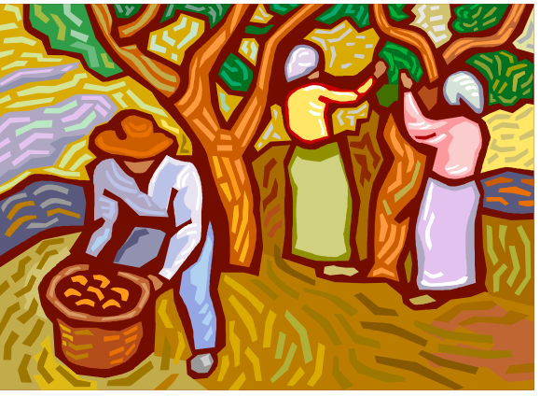

What is this workbook?

This workbook is one of two booklets co-authored by you, Justice for Migrant Workers and the Industrial Accident Victims Group of Ontario (IAVGO).

We use the term “Co-Authored” because it is recognized that it is those who read, participate and share their knowledge and experiences are in reality authors of this book.

How this Book Works

Many workers have raised several concerns about human rights violations while in Canada.

The two books are designed as a tool to:

- Begin a dialogue about human rights and the rights of migrant workers

- Learn about human rights protections in Ontario

- Talk about strategies to protect and enforce our rights

- Promote discussion and ideas for creating change

What you will need to do this Workshop

√ A Facilitator
√ Pens
√ Sticky/Post-It Notes or Paper and Tape (optional)

Before Starting…Can we agree on a learning contact for the discussion?

This meeting is a chance for discussion. Before starting, one suggestion is to collectively decide on a learning contract among participants.

Suggested components include:
- If someone is talking, don’t interrupt
- Make sure everyone gets a chance to
participate (which could include offering the floor to quiet people)
- All questions and comments are valid
- Respect each other – make a safe space for everyone
- Respect gender and racial differences
- Confidentiality – we agree to not share others’ personal stories outside the workshop

Can you identify other ideas that should be part of this contract?

Notes


1. Discussion
“Expectations”

What were our expectations when we decided to come to Canada?

Were those expectations met?

(Note: The facilitator should remember or write down the responses in preparation for the next exercise)

2. Exercise
“Where the Wind Blows”

Instructions: This exercise is called “Where the Wind Blows”. The facilitator says, “The wind blows for anyone who has ever…(for example, wanted a better life for their family)”. Whoever the statement applies to gets up and finds another seat from someone who also gets up and moves.

Note: The facilitator could incorporate the responses from Discussion 1 in this exercise.

Samples:
“The wind blows for anybody who has ever….”
- Worked in a migration program
- Has know someone who has been injured
- Thought about permanently living in Canada
- Wanted to be treated better by the employer
- Been afraid to stand up to the boss
- Wanted better housing
- Been treated differently because I speak a different language, or my way of speaking sounds different, from the local people
- Been treated differently because of the colour of my skin
- Been treated differently because I am a woman

Discussion of Exercise: - So, everyone is all scrambled up because we have all been affected by these issues in some way. Everyone is close to these experiences and conditions. It’s important to recognize that it’s not just one bad employer or one of us who has these experiences and expectations – it’s a system that allows these things to happen.

Take a look at the cartoon on the next page. Discuss: What does systemic mean to you?

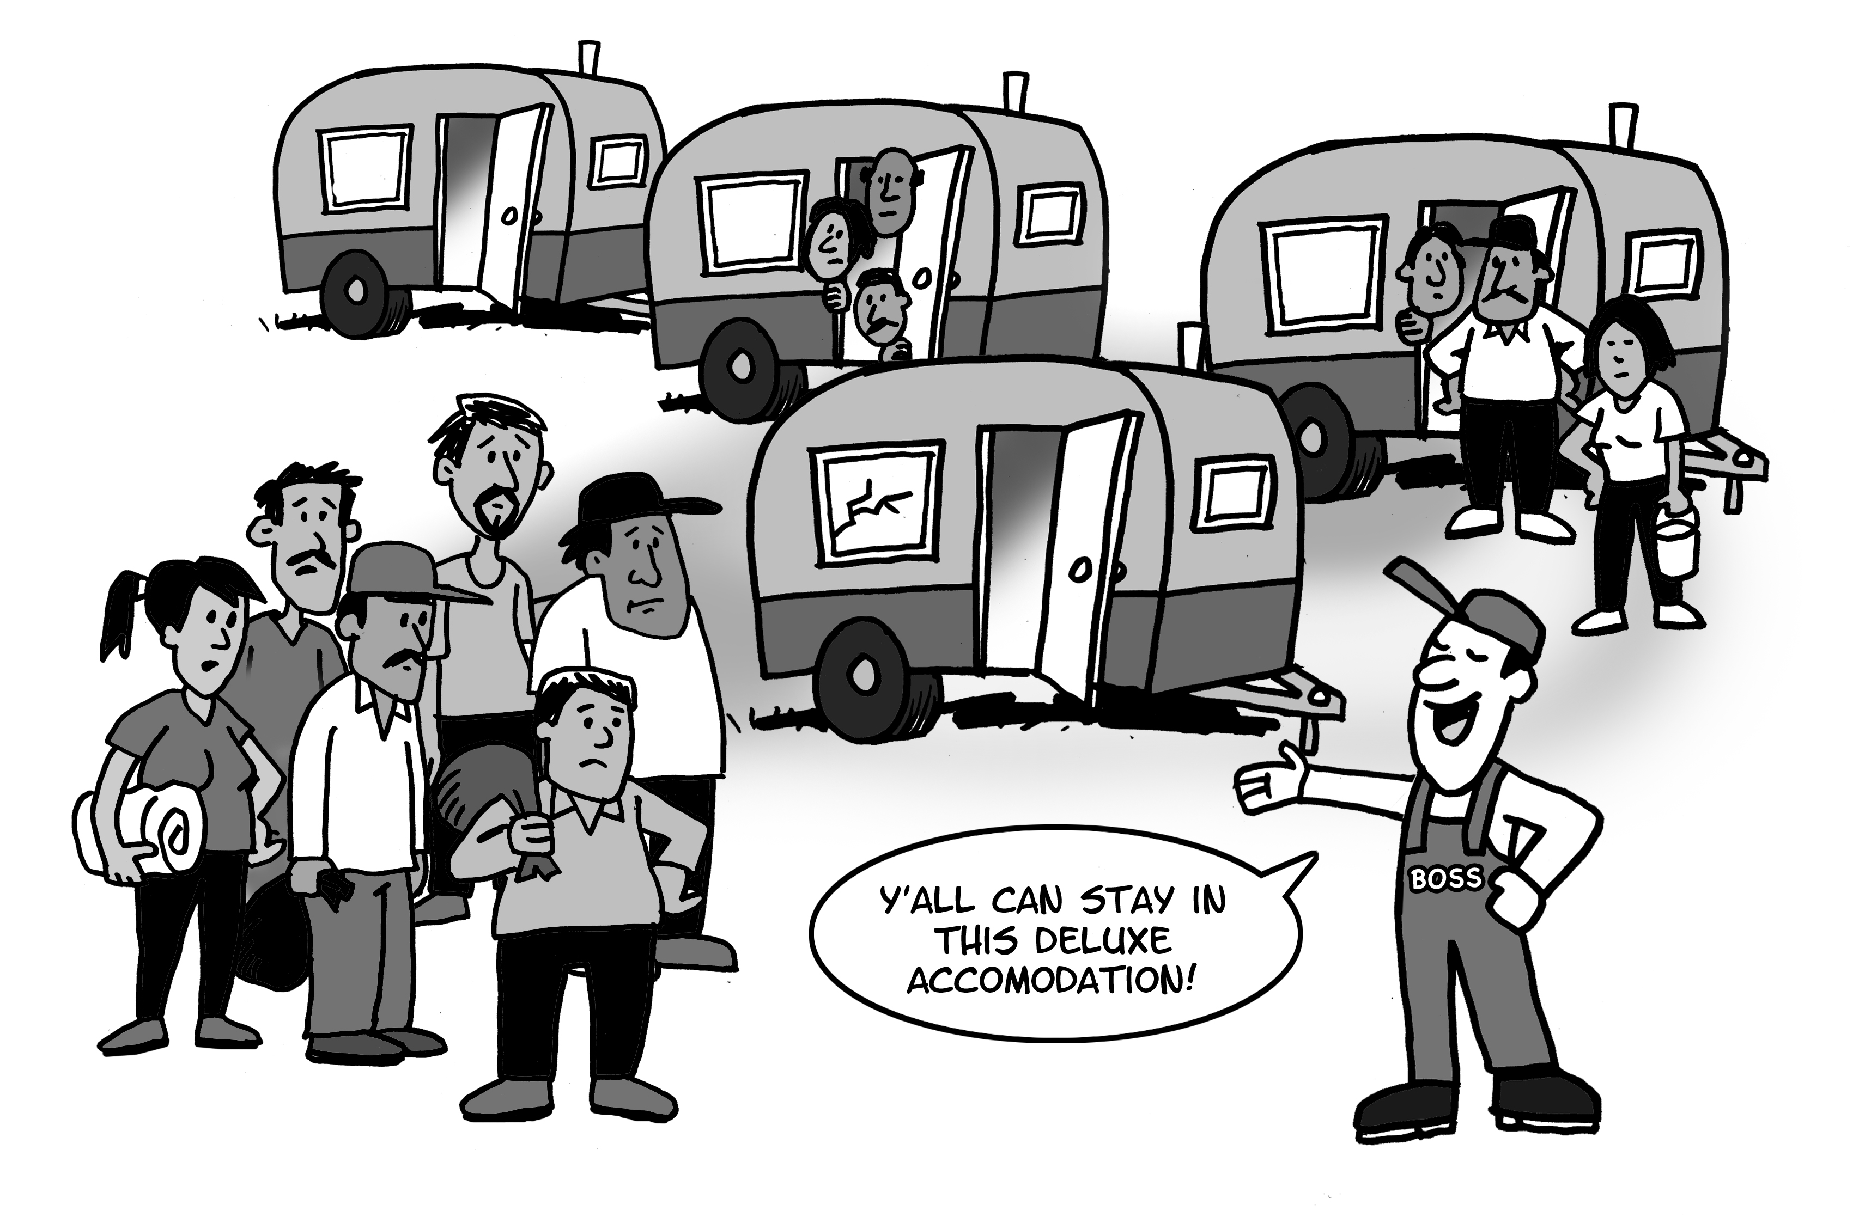

3. Exercise
“What is wrong here?”

Instructions: Break out into groups if you are in a large group. Each group should choose a different skit to act out (one group can do both A&B). If you are in a small group, choose one or two skits to act out.

Something doesn’t seem fair in each skit. After acting out the skit, discuss what went wrong in each situation.
________________________________________________

A) “Language Barriers”

Boss: What happened here? Both of you tell me right now.

Yoel: I was picking apples and Zair came up and pushed over my ladder for no reason! He’s got it in for me.

Zair : No lo empujé intencionalmente y él lo sabe. Me resbalé cuando estaba levantando una cesta de manzanas y accidentalmente golpeé su escalera. El está tratando de meterme en problemas porque piensa que
yo le quité su comida anoche, pero no es verdad. Esto fue un accidente.

Boss: You need to watch yourself Zair! If I see any more problems from you you’re gone, do you understand?!?!

Discuss: what is wrong here?

B) “Injured Worker”

Napa: Hey boss. I hurt my back while picking cucumbers. The doctor said that I need to do light work.

Boss: No body gets any privileges on this farm. Everybody has got to do the same job and you’re no exception.

Napa: But boss, my back is really sore. I can’t bend until it gets better.

Boss: No special treatment, Napa. I treat everybody equally.

Discuss: what is wrong here?

C) “Inclusive Discussion”

Roberto: (Coming out of a meeting) That was a good meeting, wasn’t it?

Feliciana: Yes. I feel like we made some good progress. But, I’m a little concerned that none of the other women are saying much.

Roberto: What do you mean?

Feliciana: Well, have you noticed that it’s mostly the men who are talking?

Roberto: The women could talk if they wanted to.

Feliciana: Yes, but maybe you and the other men should take a step back, let the women have the chance to engage in these discussions as equal participants and not as spectators.

Roberto: I don’t see why I need to do that. Like I said, the women could talk if they wanted to.

Feliciana: Think of it this way, if you were in a meeting and the boss talked at you for the entire meeting and did not give you the chance to raise issues, how would you feel?
I think if you tried to have better body language with the women, tried to direct your comments towards us, then maybe more women would participate.

Roberto: I’m not trying to exclude the women. I’m just talking to whoever was talking last.

Feliciana: I know. It’s not intentional, but the effect is that none of the women are talking.

Roberto: That’s not my problem.

Discuss: what is wrong here?

D) “Equal Access to Education”

News Anchorman: We are just getting in some breaking news. The government has decided to undertake a new program that will give equal access to education for every child in (Mexico/Jamaica/Thailand)!

Husband: That’s great!

News Anchorman: The government will give $50 dollars to the parents of each and every child in the country so they can invest in their child’s education.

Wife: Huh? $50 for every child in the county?! $50 won’t be enough to send our daughter to school. We need more than that.

Husband: Yes, and some rich people need less. Equal access to education?!?! Who is that anchorman trying to fool?

Discuss: what is wrong here?
Bonus: what might equal access to education look like? ________________________________________________

Discussion of Exercise: Ask a representative from each group to describe the scenario in their play and what their group determined was wrong with the situation.

Ideas to think about and discuss:
- How could the characters in the plays have responded to ensure everyone was treated fairly?
- Does being treated equally result in meaningful equality?
- Do people need to be treated differently in order to be treated fairly?
- Some people say it is not the INTENT to treat people unfairly, but the EFFECT or END RESULT that counts. What do you think?

A helpful concept is “equity”. Equity means that people need to be treated fairly, not on the basis of rigid rules that treat everyone the same, but based on what treatment they need as individuals or groups in their circumstances. It is this unique treatment that will help create equality. “Equity” focuses more on the EFFECTS of rules, policies, and practices rather than good or bad intentions.

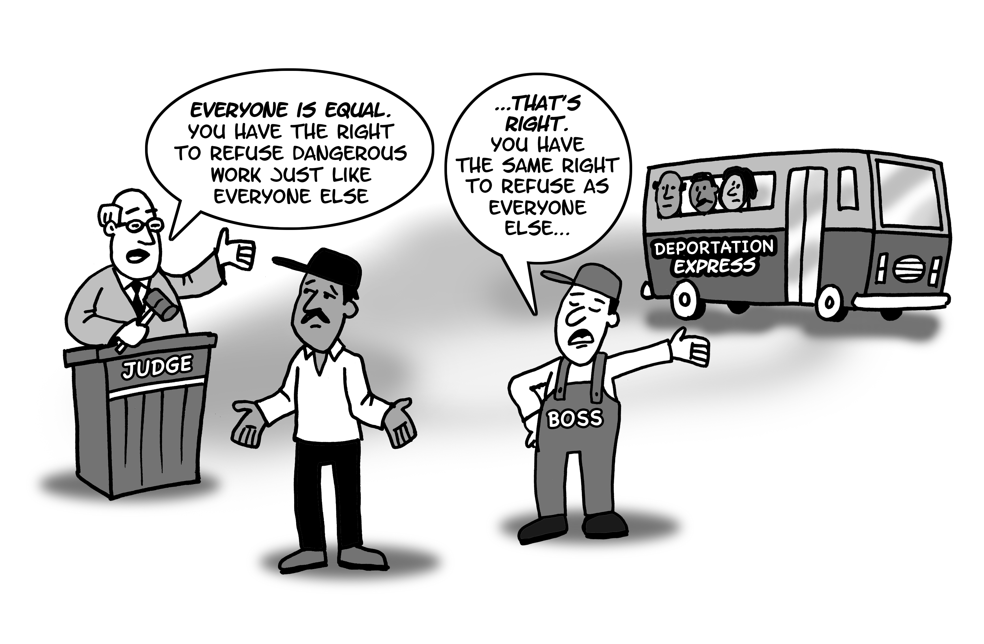

Food for thought: Is it fair that this worker is told that he has the same rights as everyone else? Why or why not? Does the judge intend to treat this worker unfairly?
Bonus: What else is unjust with this picture?

4. Exercise
“Human Rights”

Instructions: Try to brainstorm answers to the questions:
1. What is a right?
For Example: Right to safe, comfortable housing;
Right to safe conditions of work; right to access health care; etc.

2. What do we have a right to?

(Write everyone’s answers down on sticky notes or paper if possible, and post them in your space. If you don’t have sticky notes or paper and tape, write the answers on the next page).

What do we have a right to?
(use this space to write participants responses if you do not have other materials)

Food for thought: Many people make a distinction between civic and political rights (for example, right to freedom of association, right to free speech) and economic, social and cultural rights (for example, right to housing, right to food). Do you think one type of right is more important than another?

5. Discussion
“Human Rights - Part 1”

A definition of Human Rights is:

“In our day and age, all people, anywhere in the world, should have the same freedoms, opportunities, benefits, and protections in any place where they are living.”

Do you like this definition? What about it do you like or dislike? What does human rights mean to you?…Back in your home country? In Canada? While at work? At the grocery store?

Many societies, including Canada, claim that they respect human rights. According to this definition or your definition, does Canada really respect human rights? Is everyone in society able to claim the same core freedoms, opportunities, benefits and protections?

What are some examples of core freedoms, opportunities, protections and benefits that are not provided to everyone in society? Is there any from the list we made in the last exercise?

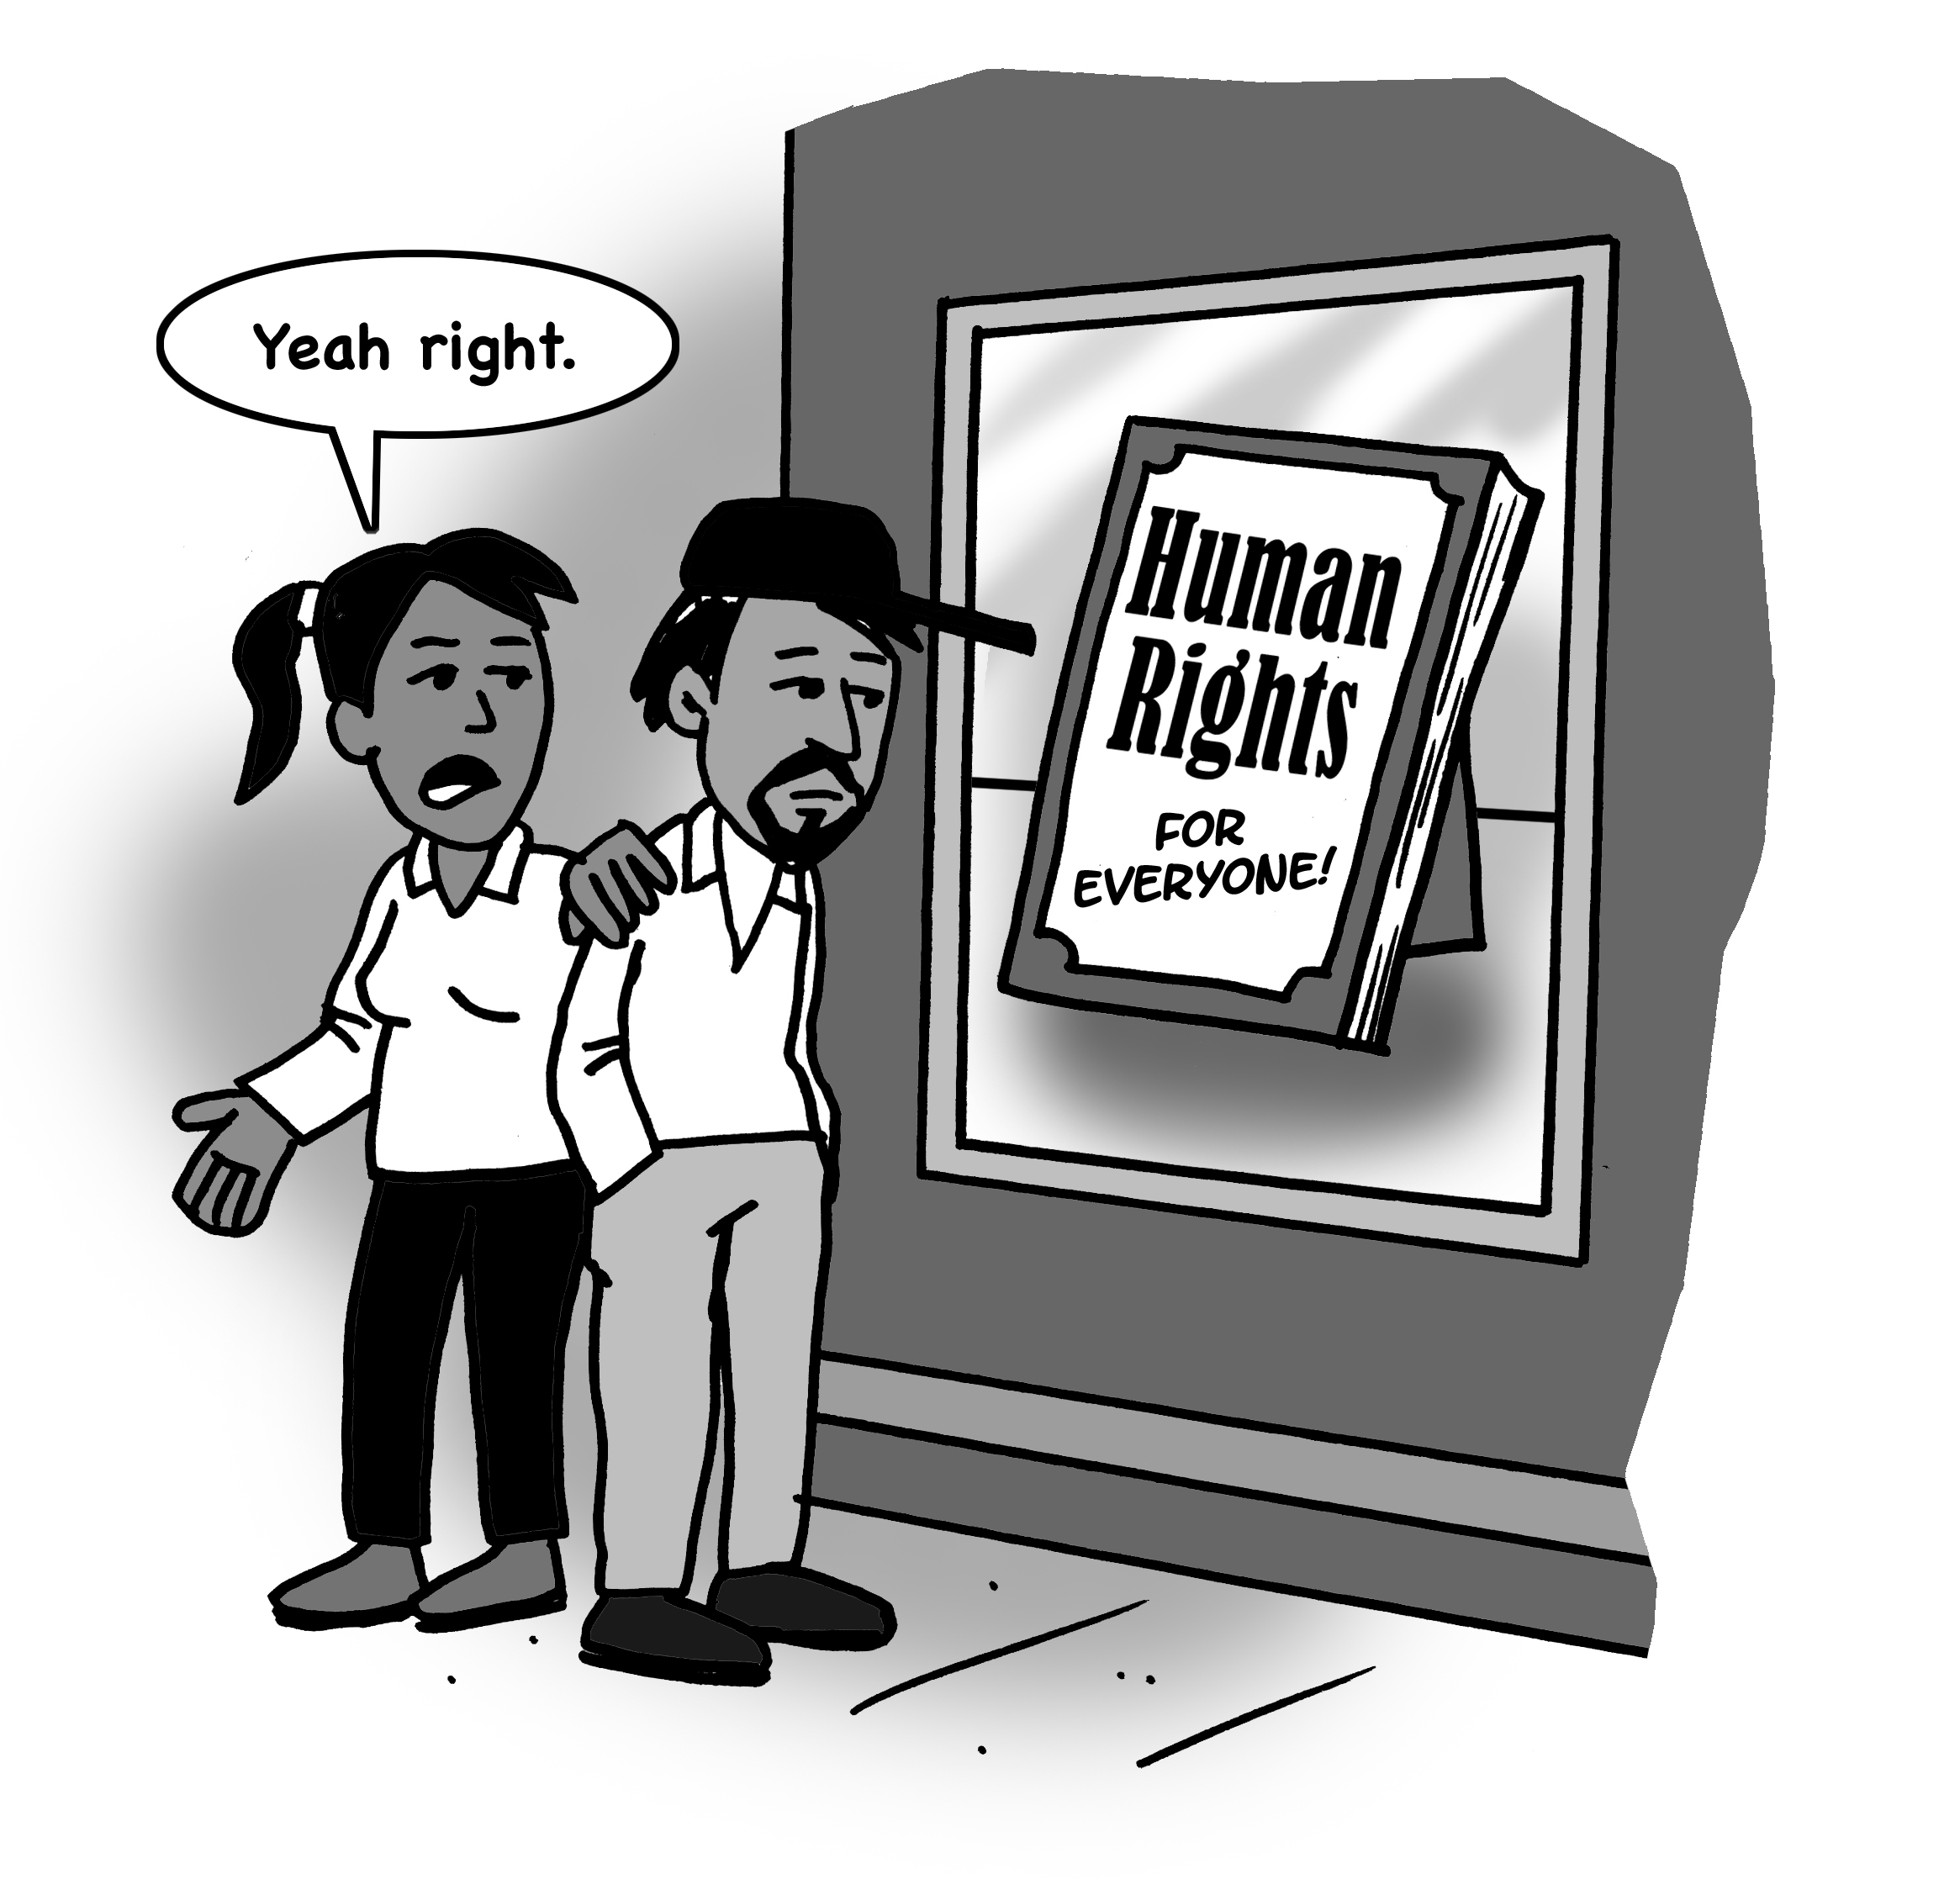

6. Discussion
“Human Rights - Part 2”

We just talked about how we deserve rights in the society in which we live. In order to stand up for those rights, it is very important to understand the law where we live.

The Ontario Human Rights Code is the law that deals with Human Rights in the province of Ontario.

To better understand how this law works, we should understand what discrimination is. Thinking about what we’ve learned so far, guess whether these statements are true or false.

True or False? “Discrimination”:
- Is denying someone a benefit because of a particular characteristic (like race, gender, or disability).
- Excluding someone from an opportunity because of a particular characteristic.
- Imposing a different obligation on someone because of a particular characteristic.
- Can happen even if there is no INTENTION to discriminate.

- Can be experienced through individuals (like comments or rules made by bosses) and systems (like policies made by service providers).
- Exists if someone’s unique needs according to a particular characteristic are not provided for.
- Exists if someone is harassing you because of a particular characteristic
The Ontario Human Rights Code does not protect against all forms of discrimination. For example, the Code does not protect against someone treating you unfairly because of your eye colour or because you have big feet. The Code only protects against discrimination in these ways:

- It outlines the “AREAS” in everyday life
where people cannot be discriminated against.

- It outlines the “GROUNDS” (personal characteristics) that cannot be the basis for discrimination.

“AREAS” in everyday life
where people cannot be discriminated against.

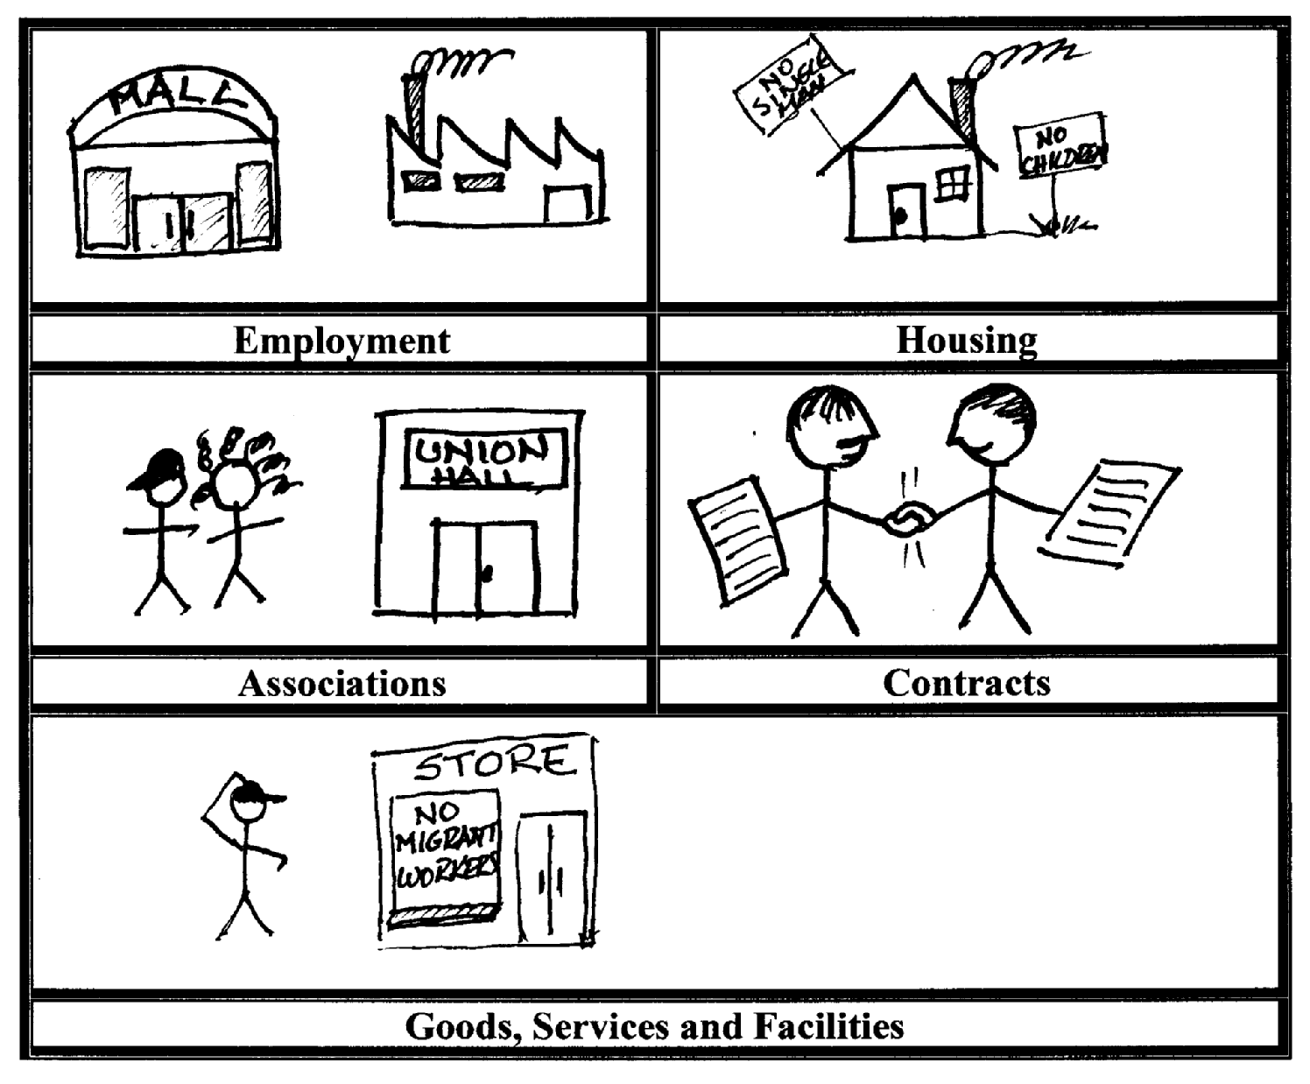

GROUNDS” (personal characteristics) that cannot be the basis for discrimination

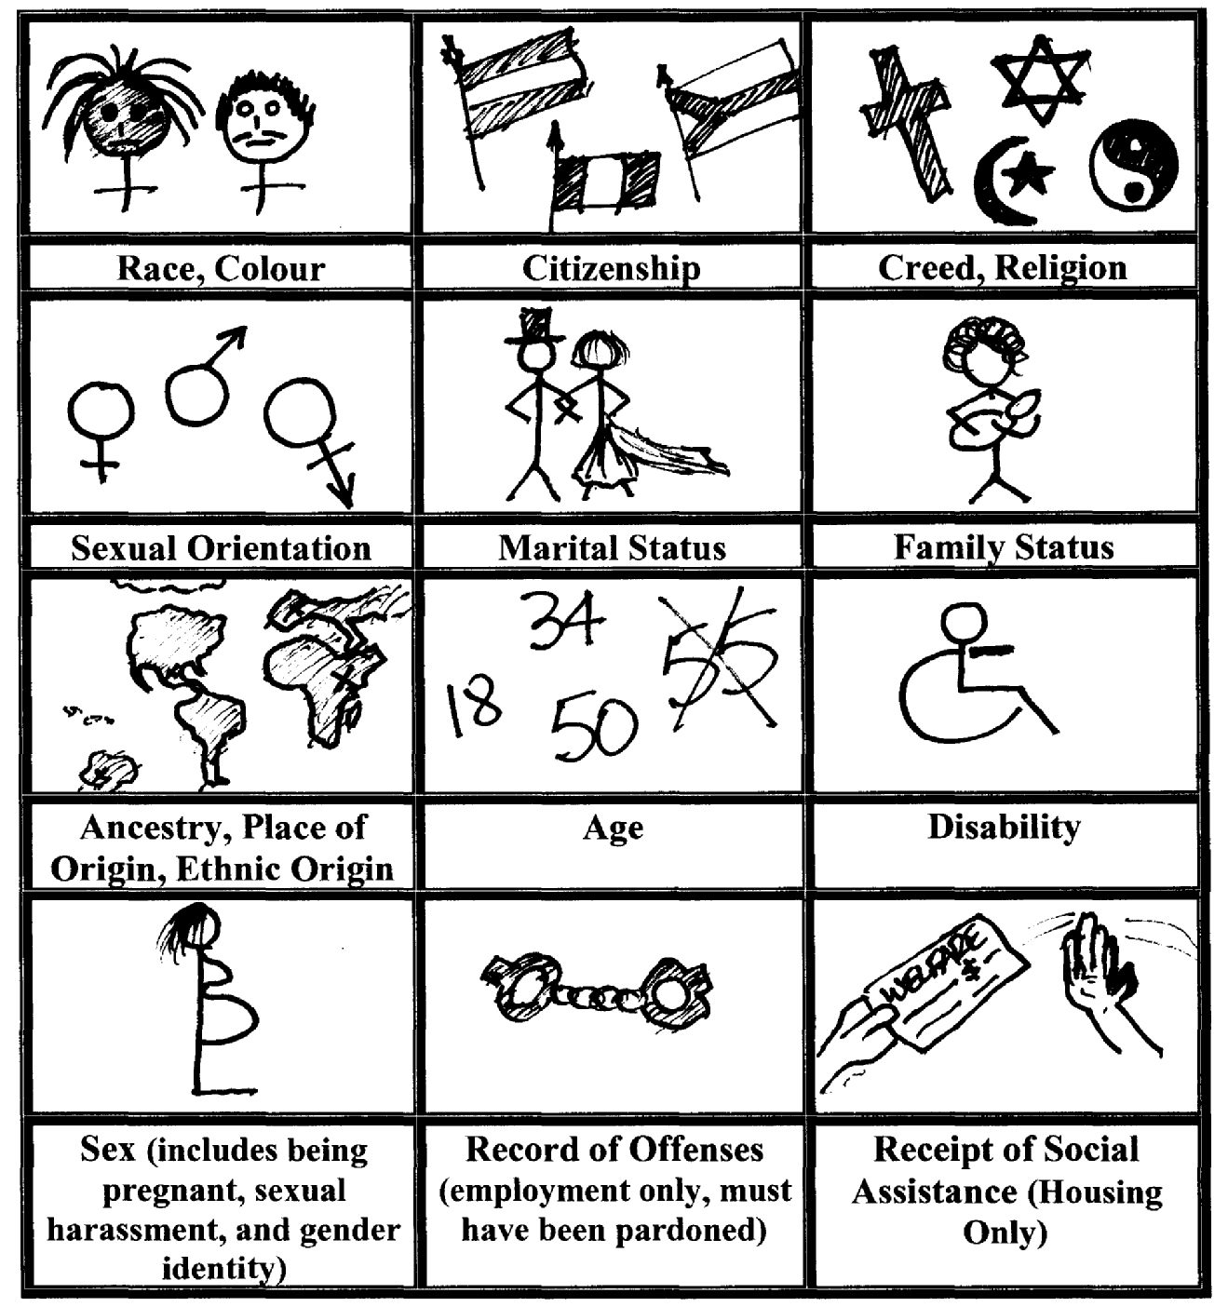

7. Exercise
“Spot the Violation”

Instructions: Identify the Area of discrimination and the Ground(s) of discrimination – there can be more than one Ground - in each of the five cartoons. Write or draw your answers here then discuss:

Cartoon | AREA | GROUND(S)
1
2
3
4
5

Cartoon 1 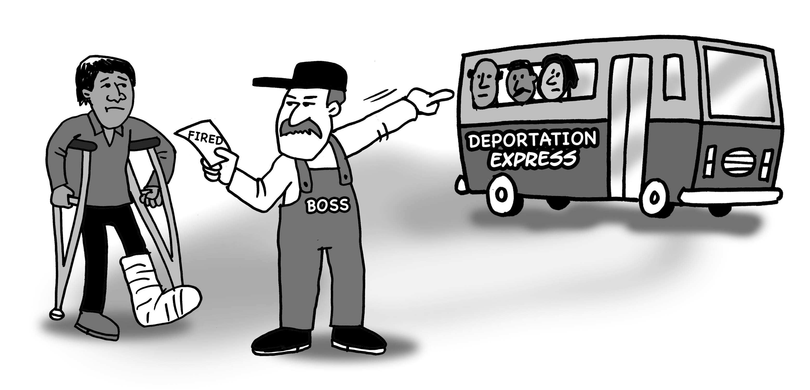

Cartoon 2 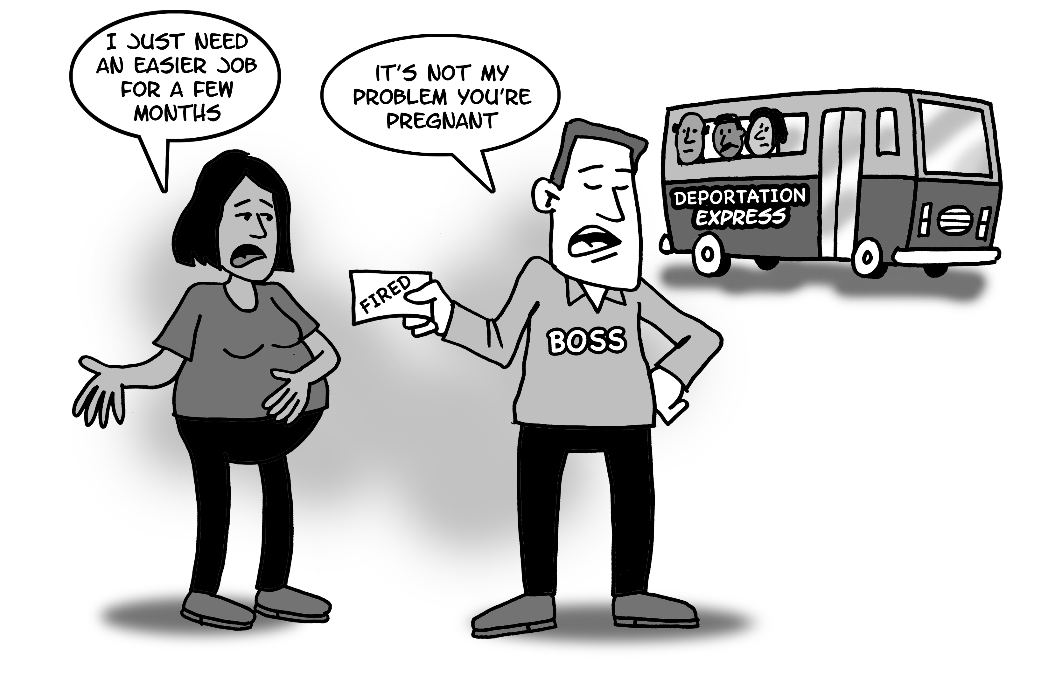

Cartoon 3 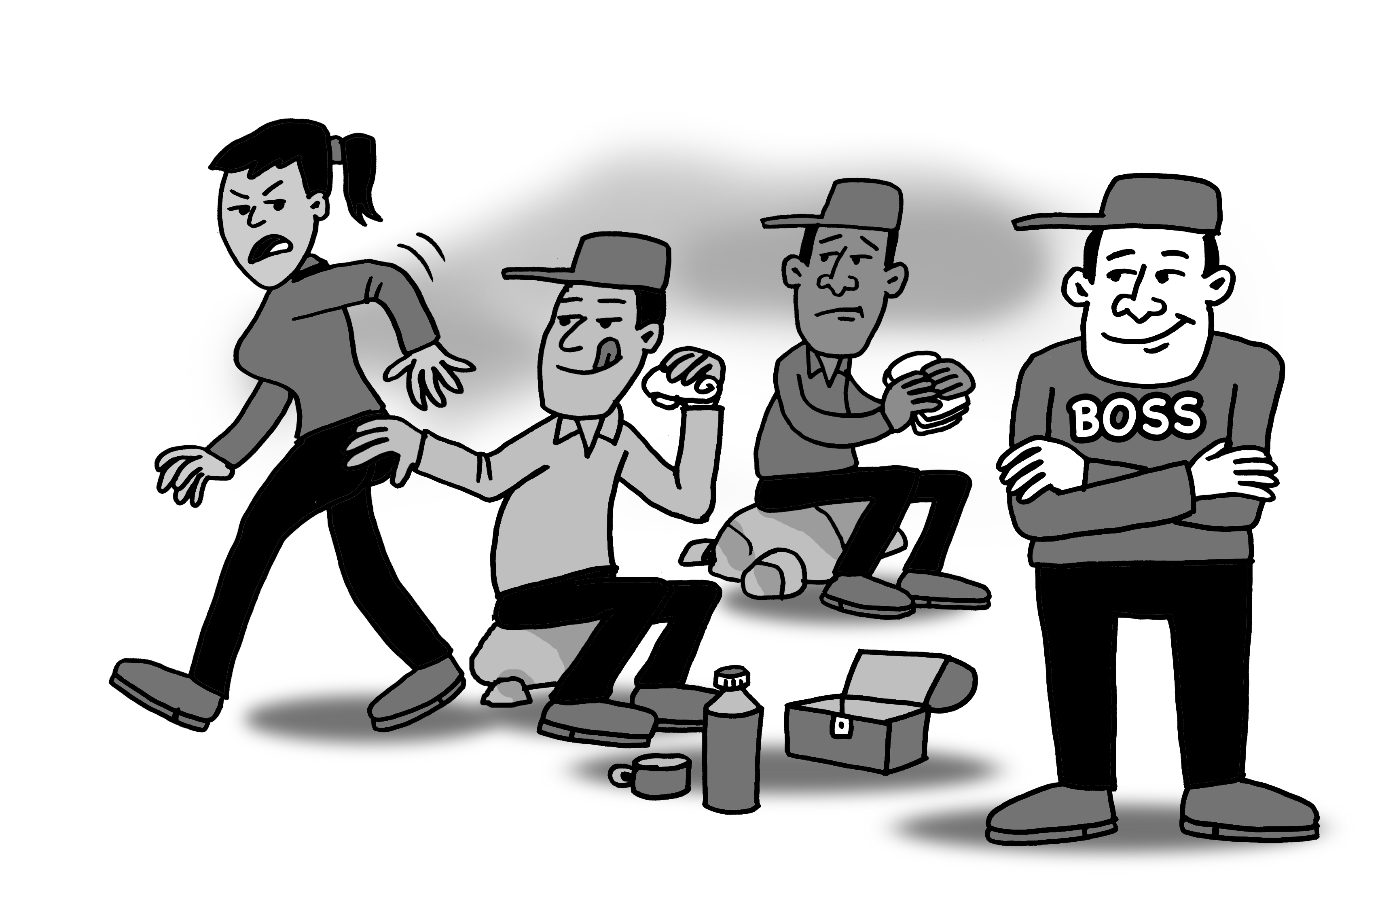

Cartoon 4
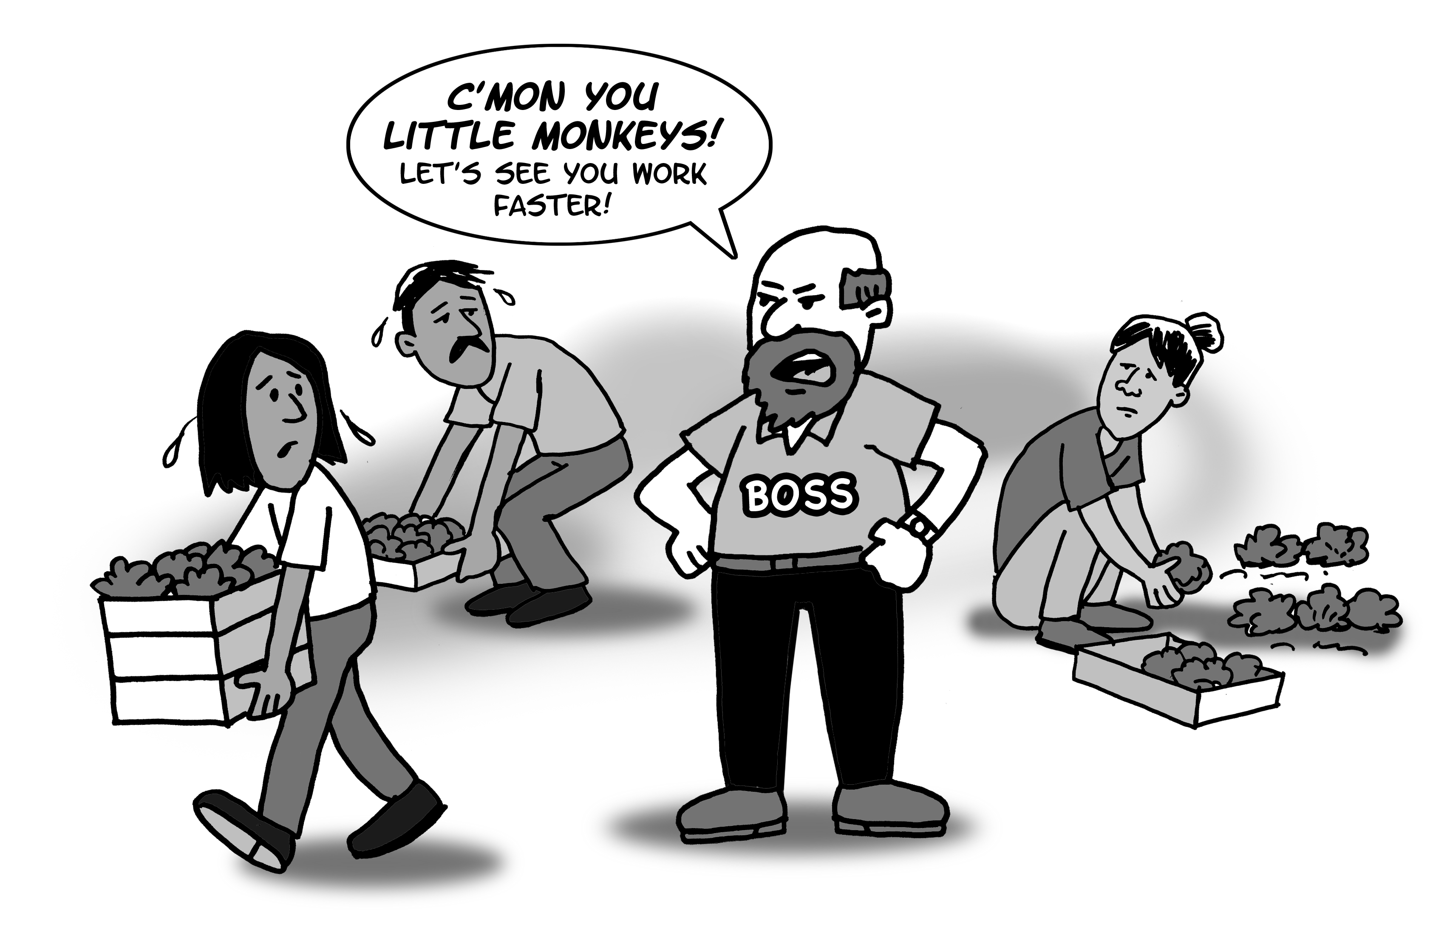

Cartoon 5
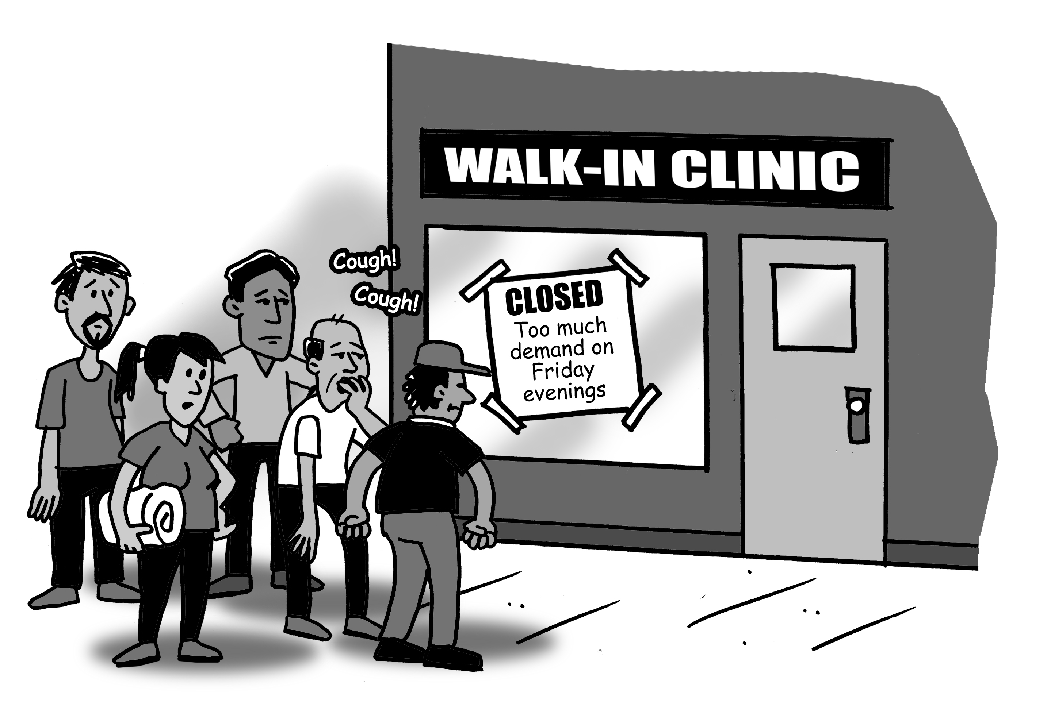

Discussion of Exercise: Now we know what the law says and now we can identify the violation. This is important to knowing what our rights are if we are experiencing discrimination. However, we also need to know how to protect ourselves…

Protect Yourself
- Look for support. Contact groups like Justice for Migrant Workers, Workers Action Centre, Human Rights Legal Support Centre, or a community legal aid clinic to discuss a strategy to deal with discrimination
- Write down the details of the discrimination or harassment
- Speak with other co-workers about whether they are also facing harassment or discrimination
- If you feel safe, speak to your boss or supervisor individually or in a group
- File a Human Rights complaint

Important: The law says you have one year from the incident of discrimination (or last incident if the incident is a series of incidents) to file a Human Rights complaint under the
Ontario Human Rights Code. If you want more information or to file a complaint contact:

Human Rights Legal Support Centre
Tel: (416) 314-6266
Toll Free: 1-866—625-5179
TTY: (416) 314-6651
TTY Toll Free: 1-866 612-8627
www.hrlsc.on.ca

For support regarding a workplace injury or illness contact:

Industrial Accident Victims Group of Ontario (IAVGO)
Tel: (416) 924-6477
Toll Free:1-877-230-6311
Toll Free: 1-866-521-8535
www.iavgo.org

For other types of support, contact:

Justice/Justicia for Migrant Workers (J4MW)
c/o IAVGO
Toll Free (Spanish Speaking): 1-866-521-8535
Toll Free (English Speaking): 1-877-230-6311
www.justicia4migrantworkers.org

8. Discussion
“Next Steps”

Today we learned about the Ontario Human Rights Code and the different areas and grounds where we are protected by law from discrimination. We can identify violations when they occur. We have some strategies for protecting ourselves.

We made a list of Rights that everyone should be entitled to. We talked about the importance of human rights for everyone in the society in which we live.

We discussed the concept of “equity” and saw how discrimination impacts everyone differently. We discussed the importance of the effect of an action, rather than the intention behind the act.

We started off examining our experiences and expectations in coming to Canada. We saw how all our experiences affect us individually, but are shared among the people in this room. We recognized that the problems we experience are not because of one bad employer or one bad

recruiter, but that there is a system that allows it to happen.

Now, we should discuss how we want to proceed.

Things to consider:

- Is sharing this knowledge with other people important? If so, how will we share knowledge with other people?
- A lot of issues affecting everyone were brought up. Is it important to work together on these issues?
- Do we want to meet again to continue to discuss these issues and how we can work together? If so, when?



